Job Description – ECONOMIC / SOCIAL Researcher
Location: Leicester, London or Cardiff
Team: Research and Development
Line Manager: Head of Research or Senior Researcher
Salary: £22,000 - £29,000 per annum, depending on experience

Main Purpose
This is a key role in ensuring that Learning and Work Institute has the capacity to design and deliver high-impact research and development work across all areas of our Strategic Plan. You will be responsible for undertaking high quality research and analysis on learning, work and related areas, as well as proactively supporting other colleagues across the organisation to do the same. We welcome applications from economists, social researchers and statisticians.

Duties and Responsibilities
- Proactively work with colleagues across the organisation to ensure that L&W’s work is effectively underpinned by robust research evidence.
- In collaboration with other colleagues, design and deliver high impact research, analysis and evaluation, to time and quality expectations, within budget.
- Develop and utilise appropriate research and analytical methods, evaluation strategies, and research tools.
- Develop and manage systems for gathering, recording, analysing and presenting data from a range of projects for maximum impact.
- Manage small projects and lead on elements of large projects.
- Contribute to research and policy reports, as well as internal documents. This includes working with others to develop conclusions and recommendations.
- In collaboration with Heads of Research, support the development and training of L&W colleagues to effectively utilise appropriate research methods and tools in the delivery of high quality project work.
- Support income generation, in collaboration with other L&W staff, including contributing to the preparation of funding proposals.
- Represent L&W at external meetings.
- Occasionally undertake public speaking/ presentations with support as necessary.

- Undertake project administration and coordination tasks related to research activity, including data entry, recruitment and note taking.
- Supervise interns, associates and temporary staff in relation to research activity, including possible line management responsibility for research interns.
- Contribute to Learning and Work’s wider agenda of influencing policy, supporting better practice and promoting adult learning and full employment across priorities identified within the organisation’s Strategic Plan.
- Demonstrate a commitment to equality of opportunity.
- Travel and occasional overnight stays will be required.

Person Specification
 | Essential/Desirable
Degree (in a relevant subject), equivalent qualifications or equivalent experience in research and development, economics or statistics | E

Skills
Well-developed communication and interpersonal skills with the ability to engage a range of audiences, stakeholders, funders and partners. | E
Excellent organisational and planning skills, that ensure work is effectively prioritised to meet deadlines. | E
Good economic / statistical / quantitative / qualitative research skills. | E
Ability to develop and utilise appropriate methods and tools to support high quality research. | E
Ability to robustly collect and analyse data that supports the reach and impact of Learning and Work’s research, development and policy work. | E
Ability to work, unsupervised, under own initiative with a proactive approach to problem solving. | E
Ability to write for and speak to a range of audiences to ensure impact. | E
Excellent use of Microsoft Office suite (in particular, Word, Excel and PowerPoint) | E
Ability to use quantitative and/or qualitative data analysis software packages (for example, R, STATA, SPSS, Nvivo etc). | D

Knowledge
Understanding and use of a range of research and evaluation methodologies and methods. | E
Understanding of learning, skills and/or employment policy and/or practice across England and/or Wales. | D

Experience
Strong track record of organising, co-ordinating and managing a range of activities against competing deadlines and priorities. | E
Experience of undertaking research with vulnerable groups | D
A commitment to the values of L&W | D
Experience of undertaking policy-related research projects, using a range of research methods | D

Learning and Work Institute works in both England and Wales, and research staff are expected to work across the organisation. Our work in Wales is led by a Cardiff based team, but all staff are required to follow the guidance set out in our Welsh language scheme when working in Wales.
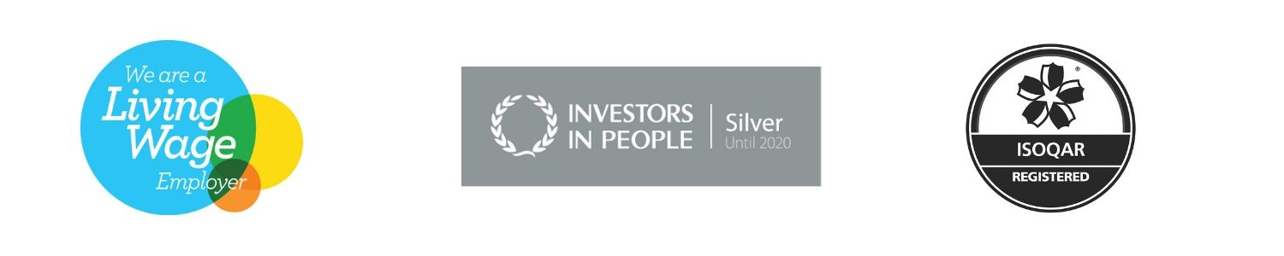Reviewed: November 2018

