Adult Learning in Wales – motivated and aspiring for better futures but still there are barriers to further and higher education.
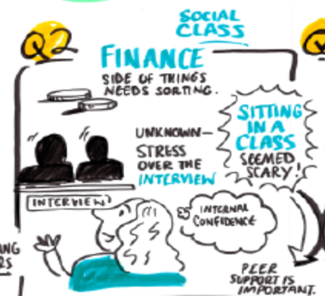
By Mark Jones

Mark is director at Higher Plain Research and Education and former Associate Professor of Education. Mark is a Senior Fellow of the Higher Education Academy and a professionally qualified youth and community practitioner.
The need for a Welsh understanding of adult learning in respect of Further Education and Higher Education
This research was in partnership with the Learning and Work Institute Cymru to gain greater insight into adult learner experiences of further and higher education in Wales as this is largely a missing voice from the recent literature. Higher Education is in need of developing a more inclusive approach to widening access in Wales that does not exclude non-traditional learners in favour of the more profitable cohorts of younger students (Evans, et al, 2017). This research sought to explore and understand the motivations, aspirations and barriers to adult learning within a further and higher education context.
An emerging approach to qualitative data collection and analysis called Pictorial Narrative Approach (Lapum et al., 2015) was adopted and supported by a short nation-wide survey providing quantitative data from over 200 adult learners in Wales. The Pictorial Narrative Approach approach enabled members in focus groups to vocalise their response whilst observing the analyst draw her interpretations of their views.
The Experiences of Adult Learners
The focus groups explored nine areas of interest evident within the literature and this created key themes that were further supported by the survey findings.

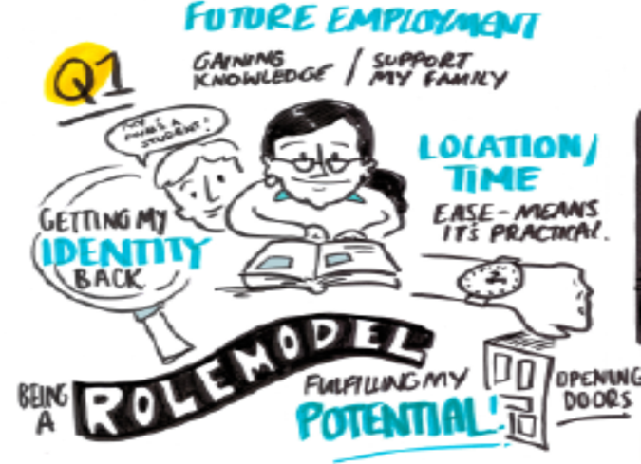
Motivations to learn
The motivations that provided most passion and importance were the more intrinsic reasons such as family and friends and particularly providing positive role modelling to younger family members and own children. There was also the notion of developing greater self-respect, self-worth, reaching their full potential and providing future opportunities for employment or progression within employment. Higher education was therefore seen to ‘open up doors for a more secure future’ and was a way of ‘getting my identity back’ and it was also a real motivation to simply learn new knowledge and skills and increase social opportunities.
Barriers and challenges to further and higher education
The main challenges faced was ‘access’ in terms of finding and accessing the right course and associated information, fulfilling the entry requirements and if there was an interview process. It was also a challenge accessing the university environment, the setting and time requirements and travelling to and from the university. There was a significant perception that they were the ‘wrong social class’ for university and that they ’felt too old and stupid’ for university or college. The university ‘system’ was seen as a ‘big scary thing’ and many stated that if their course was not delivered in the community then they would never have started the course. There was a significant fear of the university setting and feeling ‘judged’ and ‘looked down on’ as they looked different to a ‘normal’ student which was described as ‘young, 18 to early 20’s and middle class.’
The survey results supported the focus group narratives with the most common barriers were finding the time to attend classes (29%), paying for the course (28%), finding the right information (23%), confidence (23%), and accessing information and advice (17%).
Once adult learners had started their education they still expressed continued fear and anxiety associated with being able to continue and successfully complete their learning. There were feelings of being ‘out of my comfort zone’ and that having to ‘juggle everything’ in their life was stressful due to many other commitments and responsibilities such as work and family. It was common that many stated that ‘University is still scary,’ that the campus was intimidating, and that they felt they didn’t really fit in and were seen as ‘outsiders.’
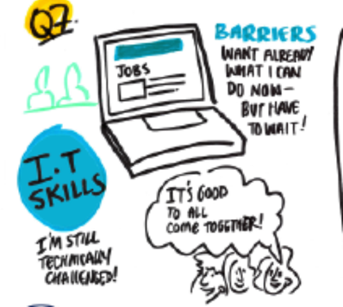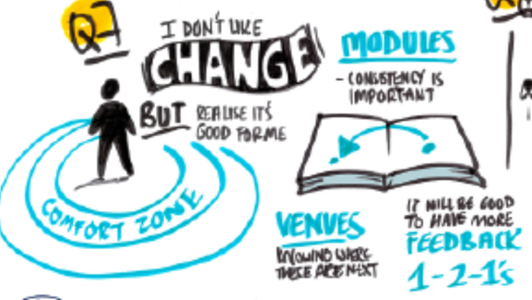
Adult Learner needs
It was clear that university quite often does not meet adult learners’ needs with improvements needed on access and consistency of feedback, teaching, and employability advice and guidance to support the planning and achievement of future life goals. Again, the strong narrative was that universities are set-up for 18-21 year olds and part-time adult learners were just an afterthought at best and often completely over-looked in terms of appropriate support services.
The most dominant support needs highlighted was the creation of a culture and approach that felt safe and secure for learners. To achieve this there was a need for learning within a community setting with high quality tutors that offered a small group approach of 8-14 learners. The needed teaching style was characterised as interactive and supportive with a blended approach to delivery using both online and face to face opportunities. The participation in an introductory course also facilitated greater confidence and motivation that they could achieve at this level of study. It was also agreed that such a community approach created strong learning communities with strong peer support and greater resilience to the challenges of further and higher education.
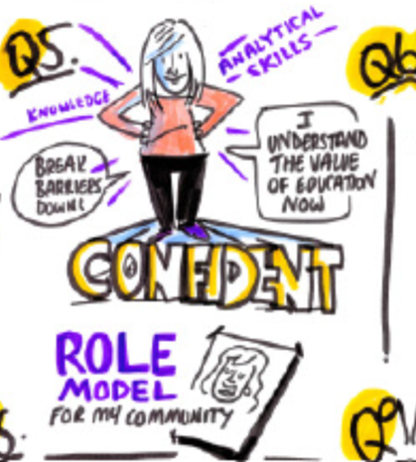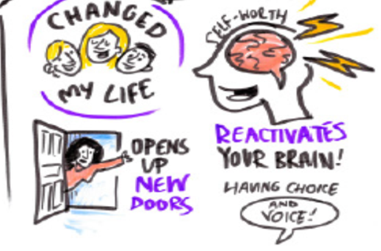
Conclusions and Recommendations
The inspiring personal stories of adult learners in this research are colourfully evident from the vibrant drawings and the power of adult education is clear to see with the main outcome shared amongst almost all of the members was a sense of pride, confidence and respect for self and own self-worth. Many identified becoming role models for their children, partner or friend and that this has given them greater self-belief for the future with many expressing ‘I feel empowered and ready for life.’
The Covid-19 pandemic is changing the way higher education is being delivered across Wales and the rest of the UK. However, the fundamentals of how providers can better engage with and support adults have remained constant. The answer lies in a number of critical developments to remove the barriers and challenges faced by adult learners and creating an updated vision and policy plan for lifelong learning in Wales.
There needs to be effective outreach and engagement of communities as part of universities civic mission. Higher education also needs to develop introductory courses that offer multiple entry points into learning using a distinct blended learning pedagogical approach within community settings. Adult learners need to be better supported and so there should be an upskilling of the adult education workforce inclusive of senior leaders, educators, and student support services. A year-round, whole system approach aimed at inspiring adults to the transformation that occurs when you become an adult learner in further and higher education is also needed. These developments and approaches all necessitate a coherent plan for lifelong learning, which will build on the new vision for the post-compulsory system published by the Welsh Government. Working with the adult learning sector, the Welsh Government should develop and publish a new lifelong learning policy. This should be far broader than the current Adult Learning Policy (2017) and encompass all parts of the adult learning sector including further and higher education sectors.
After a decade of decline there is an opportunity to build new and sustainable routes into higher levels of learning for adults in Wales. The challenge is now more urgent with the economic, social, and health and well-being consequences of the pandemic being felt in communities across Wales. The full report with clear recommendations for the Welsh Government and the higher education sector can be found here: insert link here
Finally - A big thank you to the adult learners who shared their inspiring stories with openness and honesty!

