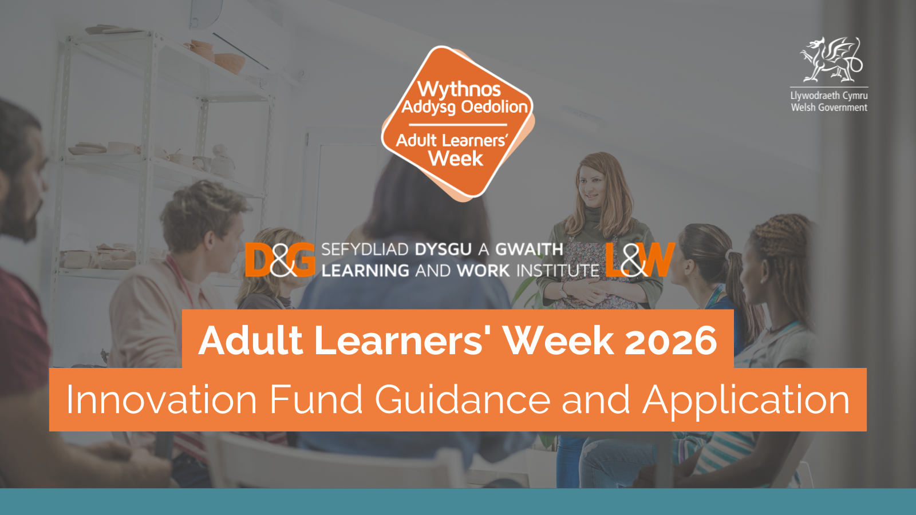
This document is available in Welsh.
About the campaign:
We want everyone to realise their ambitions and potential in learning, work and throughout life. Promoting lifelong learning and skills is a crucial part of the work that we do with campaign partners and stakeholders across Wales.

Adult Learners’ Week is an annual campaign which celebrates and promotes learning opportunities for everyone.

The campaign will run from 21 – 27 September 2026, with promotional activity taking place throughout the month.
The campaign provides a focus to promote formal and informal opportunities and to celebrate lifelong learning. We want to showcase steps back into learning and opportunities to develop skills for work, life, health, and community connections.
We want to work with you to deliver a programme of festival events for people across Wales. We’ll promote community events, short courses, taster sessions, online provision, advice, and information. We want to work with you to signpost more people to learning opportunities and to support them to get advice and information.
This fund offers support for providers of adult learning to deliver outreach, promotional activity or online tasters for the campaign week and throughout the month of September 2026.
Deadline for applications:
Friday 3 July 2026
We recommend you submit your proposal as soon as possible to allow yourself enough time to plan your programme of activity.
Please send your completed application to: alwevents@learningandwork.org.uk.
What are we looking for:
Grants of up to £750 are available to organisations working in Wales who deliver lifelong learning. This grant fund is intended to support the creation of free bitesize tasters, learning events, outreach activity, masterclasses, learner voice activities, and to develop content that can be adapted to an online environment. You may also be interested in delivering online/face to face open days – these should be focused on learning for adults. We are also interested in family learning activities to support individuals or communities.

We want you to think about tackling barriers to engage adults and families furthest away from education and employment, and to inspire more adults to find out what is available to support their learning journey and build their confidence to start.

We are interested in activity that:
- Tackles barriers to participation and to promote equality and inclusion.
- Focuses on people with low levels of skills or qualifications.
- Creates partnerships with health care to tackle health inequalities and to recognise the role of learning and skills as an important part of the solution to a healthy life.
- Builds on the enthusiasm of existing learners as advocates who use their voice and connections as a platform to encourage their own communities to take part.
- Builds a positive culture of learning, motivating as many adults as possible to see the value and the benefits of taking part and progress onto further learning.
Guidance notes - grants can be used to:
- Create online / in person bite size tasters.
- Deliver live online events and sessions.
- Co-ordinate online / in person open days for community based, family and adult learning opportunities.
- Support creative ideas to reach more adults and families with learning opportunities or to engage with information, advice and guidance. This may include the provision of opportunities that are offered at times, places and paces to reach new learners.
- Enable partnership activity to reach new audiences, test news ways of working or find new ways of promoting and delivering opportunities to reach those who need most support.
- Build more blended learning activity and support innovation in distance learning strategies.
- Focus on mental health and wellbeing by creating more opportunities for informal learning opportunities.
- Enhance inclusion by focusing on digital skills and access.

All activity must be uploaded to the Adult Learners’ Week platform and should be available for the start of September with a particular focus for Adult Learners’ Week from 21 – 27 September 2026. Funding will only be used for activities throughout September.

The Grant Fund cannot be used for:
Research projects, already established courses and hardware such as laptops or iPads.
Evidence:
We believe that the Adult Learners’ Week campaign messages are stronger across Wales if all partners utilise the same branding. You will need to use the campaign branding across your channels – website, social media, digital or print marketing assets. You will need to be able to provide evidence of your interventions and provide data/feedback to demonstrate impact.
Application form – please complete all sections:
Section 1 - Your contact details:

Name(s)
Organisation/ Partnership
Address
Email Address
Phone number

Please provide a brief overview of your organisation:

Section 2 – Details of your activity:

Grants of up to £750 are available please only apply for what you need as we’d like to spread available funding across as many organisations as possible.

Please provide the following information:
- Describe your activity / proposed project (please include a title for your event/course/activity if you have one).
- A clear budget outlining detailed costings of planned expenditure
- How much of the grant you are applying for?
- Estimated dates of activity / proposed project in September

What broad category does your activity fall into? (Please tick the subject areas that apply)
☐Construction and Trades
☐Digital skills
☐General Education
☐Health, Wellbeing and Exercise
☐Job skills
☐Languages and communications
☐Life skills
☐Life skills
☐Family learning
☐Making and creating
☐Outdoor activities and the environment
☐Reading, writing and maths
☐Science, technology, and engineering
☐Social Sciences and Humanities
☐Advice and Information
☐Other

Tell us who you are targeting and why?

Section 3 – Delivery and promotion:
Please provide a detailed explanation of the methods you will use to promote and engage participants and the specific actions you have planned. We know existing learners can inspire their friends and family, the local community - are you involving learners as part of the promotion /activity?
Please also tell us if your activities will be delivered online and specify the platform you will use (e.g. Zoom Webinar, Microsoft Teams, Google Meet).

How else will you target your audiences and promote your event or course other than the Adult Learners’ Week website?

Are you able to upload the event/course listing in Welsh and English to our Adult Learners’ Week website?

☐Yes
☐No
Please give details of your website and social media handles where relevant:

Website | www.
LinkedIn | @
Facebook link | www.facebook.com/
Instagram handle | @
YouTube link
BlueSky | @

Section 4 – Impact

How many people will you aim to target for each of your events?

There will be a media campaign to promote the Adult Learners’ Week platform of activities. How will you measure the impact and evaluate the effectiveness of your activity? We will expect to see tracking of participation figures and feedback from successful applicants.

  - Attendance figures achieved per activity / number of views
  - Number of people enquiring about further learning and/or enrolling on a course
  - Number of website clicks
  - Social media reach / impressions (likes, shares, comments)
  - Learner feedback and testimonials
  - Media engagement
  - Any other feedback

Section 5 – Grant Agreement
Please read carefully and tick to confirm the following:
☐ Should this funding application be successful, I agree to provide Learning and Work Institute with updates regarding development or changes to activities. I will also ensure we maximise our partnership through strategic branding, marketing and promotional opportunities. (Please select the checkbox to confirm).

☐ I am aware that a condition of the grant is to upload/update my event details onto the campaign website bilingually by Monday 24th August (with the ability to update/edit/remove listings during September) and for an Evaluation form to be submitted in full, to ensure payment of the grant, and any underspend will be declared. (Please select the checkbox to confirm).
Deadline and next steps:
Application deadline: Friday 3 July 2026.
We recommend you submit your proposal as soon as possible to allow yourself enough time to plan your programme of activity.
Please send your completed application to: alwevents@learningandwork.org.uk.

- If your application is successful, Learning and Work Institute will work closely with you in the lead-up to Adult Learners' Week to maximise promotion and delivery. Please ensure all event information is uploaded bilingually to our online platform.
- A fully completed evaluation form from all grant recipients will provide sufficient evidence and feedback on all areas of the original application must be submitted by Friday 16th October 2026.
- Grant payments will be processed once a completed evaluation form has been returned. Payments may be made in two phases if needed, to assist smaller organisations. Learning and Work Institute should be notified of any underspend.
Email Learning and Work Institute at alwevents@learningandwork.org.uk if you have any queries about this application.


Become a Learning and Work Institute Supporter to receive information about our latest Wales campaigns, research and events news as well as our monthly newsletter.
Go to the Supporter Network form on our website to sign up.

Please note: Learning and Work Institute will only use personal data in accordance with the terms of consent given by the individual or group.

